Good set of trace logs..

**Default Tracing**

To enable default tracing..

Add to config in WebAPIConfig class..

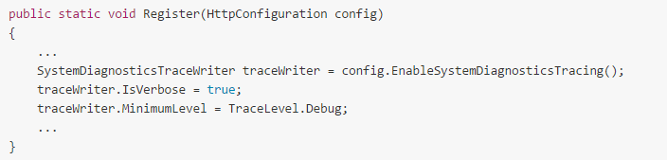

SystemDiagnosticsTraceWriter class added to the Web API pipeline.. writes traces to System.Diagnostics.Trace

If run app in debugger and issue a request.. **the trace statements are written to the Output window** ins Visual Studio..

* IsVerbose: If false, each trace contains minimal info. If true, more info.
* MinimumLevel: Sets the minimum trace level. Trace levels, in order, are Debug, Info, Warn, Error, and Fatal

**Add traces to your code**

You can also use the trace writer to trace your own code, like this:

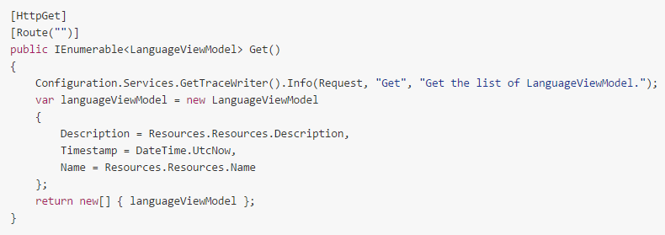

**Creating Custom Trace Writer**

Instead of using SystemDiagnosticsTraceWriter class as the trace writer.. can create your own... need to implement ItraceWriter and implement its Trace() method..

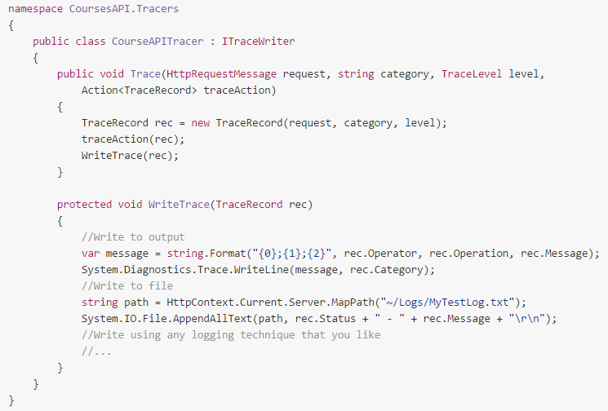

Enable it.. configure it to yuse yours.. in WebApiConfig.. bla..